Aerospace Supplier Risk Intelligence

The domain of the Project: Data Analytics

G1-DA

Team Mentors (and their designation):

Nithyasri Kannathal – Software Development Engineer II at Predigle

Team Members:
Ms. Simranjot Kaur

Period of the project

February 2026 to July 2026

Declaration
The project titled “Aerospace Supplier Risk Intelligence” has been mentored by Ms.Nithyasri Kannathal, organised by SURE Trust, from April 2023 to August 2023, for the benefit of the educated unemployed rural youth for gaining hands-on experience in working on industry relevant projects that would take them closer to the prospective employer. I declare that to the best of my knowledge the members of the team mentioned below, have worked on it successfully and enhanced their practical knowledge in the domain.

Team Members:
Ms. Simranjot Kaur
Signature: Simranjot Kaur

Mentor’s Name
Ms.Nithyasri Kannathal
Software Development Engineer II
Predigle

Prof. Radhakumari
Executive Director & Founder
SURE Trust

Table of contents
- Executive summary
- Introduction
- Project Objectives
- Methodology & Results
- Social / Industry relevance of the project
- Learning & Reflection
- Future Scope & Conclusion

Executive Summary
The Aerospace Supplier Risk Intelligence project is a data analytics and machine-learning solution developed to identify purchase orders that may be delivered late.
Procurement teams handle many suppliers, parts and purchase orders. Checking every order manually takes time and can result in important risks being identified too late. This project helps users focus on the purchase orders that require attention first.
The project uses data related to:
- 40 suppliers
- 300 parts
- 29,666 purchase orders
- 368 quality incidents
- 280,800 supply-chain history records
- 6,002 final PO prediction records
Three machine-learning models were compared: Logistic Regression, Random Forest and HistGradientBoosting. A classification threshold of 0.45 was used for the early-warning system. At this threshold, the model achieved 63.9% precision, 71.9% recall and a 67.7% F1 score.
The project generated 6,002 purchase-order alerts, including:
- 285 Critical alerts
- 2,410 High alerts
- 1,136 Medium alerts
- 2,171 Low alerts
The final results are presented through a Streamlit website and Power BI dashboards. Streamlit helps users investigate individual purchase orders, understand the main risk driver and view recommended actions. Power BI provides summary charts and management-level reporting.
The current solution is a proof-of-concept. It supports procurement decisions but does not make automatic decisions or guarantee that an order will be late.

Introduction
2.1 Background
Aerospace companies depend on suppliers for the timely delivery of important parts and materials. A delay in one critical part can affect production schedules, inventory availability and customer commitments.
Procurement teams may need to monitor thousands of purchase orders. Manually reviewing every order is difficult and time-consuming. Therefore, an early-warning system can help users identify possible delays before they create a larger operational problem.
2.2 Problem Statement
The main problem is that purchase-order risks are often identified too late.
The major business challenges are:
- Manual monitoring of thousands of purchase orders
- Difficulty in identifying high-risk orders
- Lack of clear alert priorities
- Limited explanation behind a risk score
- Difficulty in deciding what action should be taken
This project addresses these challenges by predicting PO late-delivery risk and creating a prioritised action queue.
2.3 Scope
The project covers:
- Data cleaning and validation
- Feature engineering
- SQL-based analysis
- Machine-learning model comparison
- PO late-delivery probability
- Risk categorisation
- Rule-based risk explanations
- Recommended procurement actions
- Streamlit application development
- Power BI dashboard development
2.4 Limitations
The main limitations are:
- The project is a proof-of-concept.
- It is not connected to a live ERP system.
- The Streamlit application uses prepared project output files.
- The model has moderate predictive performance.
- The explanation system is rule-based and does not use an external LLM.
- The model does not automatically approve, reject or cancel orders.
- Human review is required before taking procurement action.
- Email, Teams and n8n notifications are not currently implemented.

Project Objectives
The main objective of this project is to develop an early-warning system for purchase-order delivery risk.
The specific objectives are:
- To combine supplier, part, purchase-order, quality and historical supply-chain data.
- To clean and validate the project datasets.
- To create useful features related to supplier performance and delivery risk.
- To compare different machine-learning classification models.
- To estimate the late-delivery probability of individual purchase orders.
- To classify alerts into Critical, High, Medium and Low categories.
- To identify the main risk driver behind each alert.
- To provide simple explanations and recommended procurement actions.
- To develop an interactive Streamlit application.
- To create Power BI dashboards for visual analysis and management reporting.
- To provide a prioritised and downloadable procurement action queue.

Methodology and Results
4.1 Tools and Technologies Used
The following tools and technologies were used:
Tool | Purpose
Python | Data cleaning, analysis and machine learning
Pandas and NumPy | Data processing
Scikit-learn | Model training and evaluation
SQL | Analytical queries and reusable views
Streamlit | Interactive web application
Plotly | Interactive charts
Power BI | Dashboards and management reporting
GitHub | Project code and documentation

4.2 Dataset Description
The project uses the following datasets:
Dataset | Records | Purpose
Suppliers | 40 | Supplier information
Parts Master | 300 | Part details and criticality
Purchase Orders | 29,666 | Order and delivery information
Quality Incidents | 368 | Supplier and part quality issues
Supply-Chain History | 280,800 | Historical delivery information
PO Predictions | 6,002 | Model prediction output
Final PO Alerts | 6,002 | Priority, reason and action output

4.3 Data Cleaning and Validation
Before model development, the datasets were checked and prepared.
The main activities included:
- Checking missing values
- Checking duplicate records
- Correcting data types
- Standardising categorical values
- Checking supplier and part identifiers
- Reviewing date fields
- Confirming record counts
- Preparing clean data for analysis
Validation Results
Validation Check | Expected Result | Status
Suppliers | 40 | Passed
Parts | 300 | Passed
Purchase orders | 29,666 | Passed
Quality incidents | 368 | Passed
PO predictions | 6,002 | Passed
Final PO alerts | 6,002 | Passed
Critical alerts | 285 | Passed
Critical-part escalations | 152 | Passed
All important record-count checks were passed.
4.4 Feature Engineering
Feature engineering was performed to create useful inputs for the machine-learning models.
Important features included:
- Supplier historical late-delivery rate
- Promised lead days
- Lead-time days
- Part criticality
- Delivery risk
- Quality risk
- Compliance risk
- Operational risk
The three most important features were:
Feature | Importance | Meaning
Supplier Historical Late Rate | 29.45% | Previous supplier delivery reliability
Promised Lead Days | 13.45% | Committed delivery period
Lead Time Days | 12.61% | Time required to fulfil an order
Supplier Historical Late Rate was the most important feature. This means that a supplier’s previous delivery performance is a useful signal for identifying current PO risk.

4.5 SQL Analytics
Nine analytical SQL views were created:
- vw_SupplierRisk
- vw_SupplierRiskSummary
- vw_CriticalSupplierQueue
- vw_POPredictions
- vw_POAlertQueue
- vw_InventoryHealth
- vw_QualityIncidents
- vw_DeliveryPerformance
- vw_ExecutiveKPIs
These views organise the cleaned data into reusable outputs for analysis, reporting and dashboard development.

4.6 Machine Learning
The project was treated as a binary-classification problem. The model predicts whether a purchase order is likely to be late.
Three models were compared:
- Logistic Regression
- Random Forest
- HistGradientBoosting
Model Comparison
Model | Accuracy | ROC-AUC
Logistic Regression | 63.6% | 64.3%
Random Forest | 63.3% | 64.6%
HistGradientBoosting | 63.2% | 64.2%
Random Forest had the highest ROC-AUC, while Logistic Regression had the highest accuracy. The results of all three models were close.
The model is used as an early-warning tool. It does not guarantee that a purchase order will be late.
4.7 Threshold Results
A threshold of 0.45 was used to identify purchase orders requiring attention.
Metric | Result
Threshold | 0.45
Precision | 63.9%
Recall | 71.9%
F1 Score | 67.7%
Alert Rate | 63.8%
ROC-AUC | Approximately 0.64
Recall was important because the aim was to identify as many possible late-risk purchase orders as reasonably possible.
A recall of 71.9% means that the model identified approximately 71.9% of the late-risk cases in the evaluated data.

4.8 Risk Analysis
The 6,002 prediction records were divided into four alert categories.
Alert Priority | Number of Alerts | Percentage
Critical | 285 | 4.7%
High | 2,410 | 40.2%
Medium | 1,136 | 18.9%
Low | 2,171 | 36.2%
Total | 6,002 | 100%
Important results include:
- 2,695 Critical and High alerts
- 285 Critical alerts
- 152 critical-part escalations
- 6,002 total PO alerts
Alerts are prioritised in the following order:
Critical → High → Medium → Low
Within each category, orders with a higher late-delivery probability are displayed first.
4.9 Explainable Risk Recommendations
The project includes a rule-based explanation system.
The explanation workflow is:
Risk Probability → Primary Risk Driver → Explanation → Recommended Action
The system explains the main reason behind an alert and suggests an appropriate procurement action.
Example actions include:
- Contact the supplier.
- Confirm the delivery date.
- Request a recovery plan.
- Increase monitoring.
- Review alternate suppliers.
- Escalate a critical-part order.
The explanation system is rule-based. It does not use ChatGPT or another external Large Language Model.

4.10 Streamlit Application
The Streamlit website is the interactive decision-support part of the project.
It contains the following pages:
- Project Overview
- Data and SQL Pipeline
- Machine Learning
- Explainable Risk Recommendations
- Procurement Decision Center
- Power BI Dashboard Showcase
The website allows users to:
- Review project KPIs
- Compare machine-learning models
- Select suppliers and purchase orders
- View late-delivery probability
- Identify the primary risk driver
- Read the risk explanation
- View the recommended action
- Filter alerts
- Download the procurement action queue
The Streamlit application supports detailed PO-level investigation.
4.11 Power BI Dashboards
Five Power BI dashboard pages were created:
- Executive Control Tower
- Supplier Risk Analysis
- Predictive Delivery Risk
- Quality and Inventory Risk
- Procurement Action Queue
Power BI provides summary charts, KPIs and management-level analysis.
The difference between Streamlit and Power BI is:
- Streamlit supports detailed PO investigation, explanation and action.
- Power BI provides overall visual analysis and reporting.

4.12 Project Architecture
The project follows this workflow:
CopyRaw Data
↓
Data Cleaning
↓
Data Validation
↓
Feature Engineering
↓
Machine-Learning Prediction
↓
Risk Categorisation
↓
Risk Explanation
↓
Recommended Action
↓
Streamlit Application and Power BI Dashboards
This architecture connects raw data with practical procurement decisions.

4.13 Working Screenshots
Insert the following screenshots in this section:
1: Project Overview
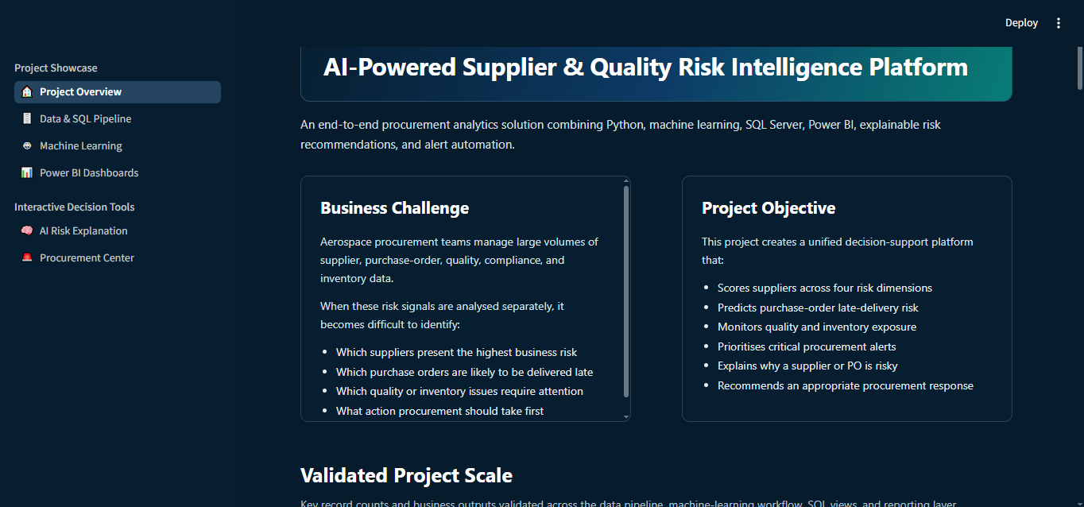
This page displays the project summary, KPIs and architecture.
2: Data and SQL Pipeline
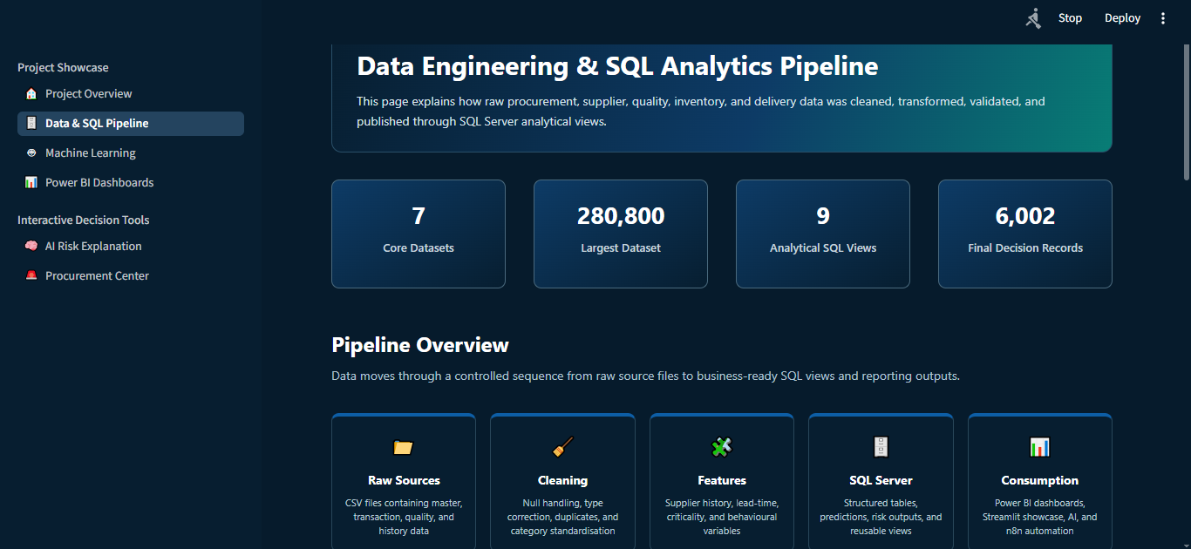
This page shows datasets, cleaning steps, validation checks and SQL views.
3: Machine Learning
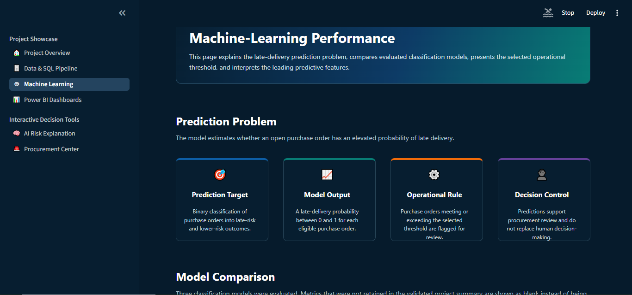
This page shows model comparison, threshold metrics and feature importance.
4: Explainable Risk Recommendations
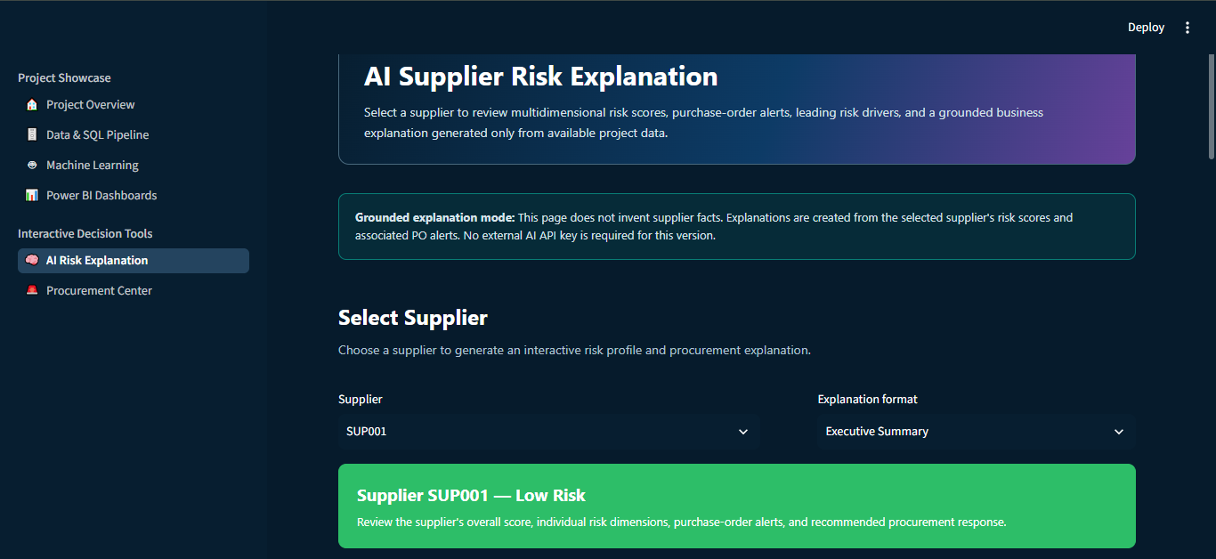
This page displays the risk probability, primary risk driver, explanation and recommended action.
5: Procurement Decision Center
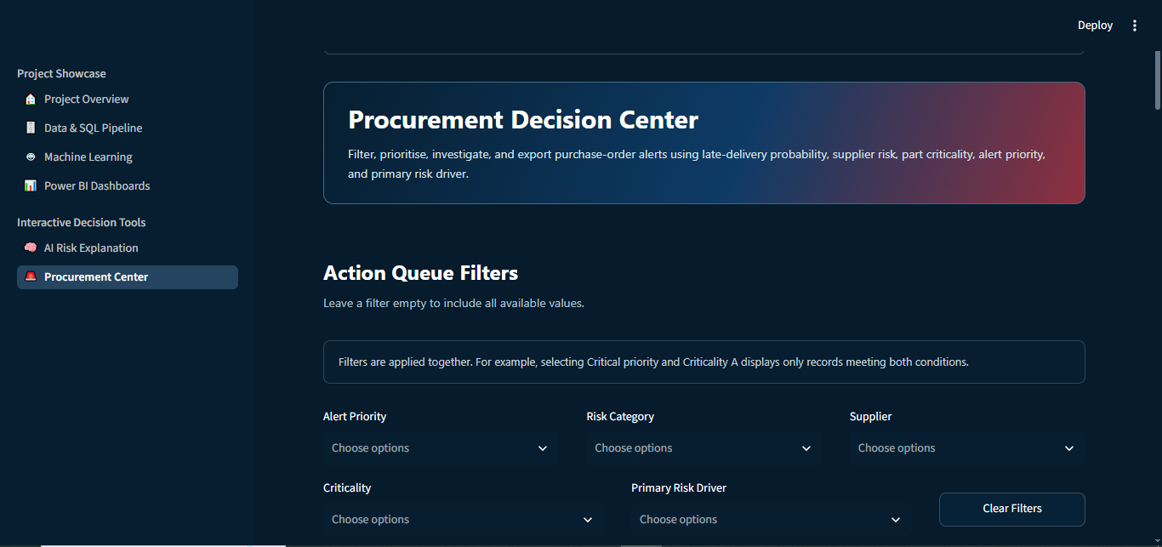
This page allows users to filter alerts and review individual purchase orders.
6: Power BI Dashboard
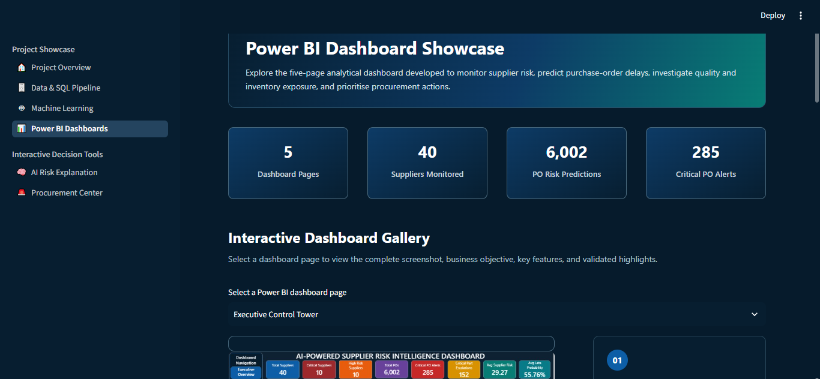
The Power BI dashboards provide summary visualisations and procurement KPIs.
4.14 GitHub Link
The project source code, SQL files and documentation are available at:
GitHub Repository Link: https://github.com/simranjot21/aerospace-supplier-risk-intelligence
Suggested repository name:
aerospace-supplier-risk-intelligence

Learning and Reflection
This project helped me understand how a business problem can be converted into a complete data analytics and machine-learning solution.
I learned how to:
- Understand a procurement business problem
- Work with multiple datasets
- Clean and validate data
- Create useful analytical features
- Develop SQL views
- Compare machine-learning models
- Understand precision, recall, F1 score and ROC-AUC
- Create an interactive Streamlit application
- Design Power BI dashboards
- Explain technical results in simple business language
- Create a prioritised action queue
The most important learning was that a prediction alone is not enough. Users also need to understand why a purchase order is risky and what action they should take.
I also learned that machine-learning models are not always perfect. The results must be explained honestly, and final decisions should remain with the user.
This project improved my technical knowledge, problem-solving ability, communication skills and confidence in working on an end-to-end data analytics project.

Conclusion and Future Scope
7.1 Future Scope
The project can be improved in the future by adding:
- Live ERP and SQL integration
- Automatic scoring of new purchase orders
- Email or Microsoft Teams notifications
- Optional workflow automation using n8n
- Buyer feedback collection
- Model monitoring and retraining
- Role-based access
- Supplier capacity and logistics data
- Production deployment with secure authentication
Notification automation and n8n were not implemented in the current project. They are included only as future improvements.
7.2 Conclusion
The Aerospace Supplier Risk Intelligence project was developed to identify purchase orders that may be delivered late.
The project successfully combined data cleaning, SQL analytics, machine learning, risk explanation, Streamlit and Power BI into one decision-support workflow.
It generated 6,002 PO alerts, including 285 Critical alerts and 152 critical-part escalations. The selected threshold achieved 71.9% recall, 63.9% precision and a 67.7% F1 score.
The Streamlit application helps users investigate individual purchase orders, understand the primary risk driver and review recommended actions. Power BI provides overall visual analysis and management reporting.
The project is currently a proof-of-concept. It does not make automatic procurement decisions and does not guarantee that a purchase order will be late. However, it shows how data analytics and machine learning can help procurement teams move from manual and reactive monitoring towards a more proactive and organised approach.

